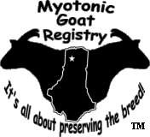

Route 66 Myotonic Classic

Show A @ 4:00 pm (6/1/2018)
*Sponsored by Wallace’s Crazy Acres*

Show B @ 8:00am (6/2/2018)
*Sponsored by Naughty Goat Acres*

Show C @ 1:30 pm (6/2/2018)
*Sponsored by Bureau Creek Family Farm*

Illinois State Fairgrounds North Sheep Barn
801 E. Sangamon Ave. Springfield, IL 62702

If you will be showing, in ONE show only, select either SHOW A, SHOW B, OR SHOW C; if you are showing in all three then please check all (SHOW A, SHOW B, SHOW C) and fill out the information and mail it to the Show Secretary.

MGR Show rules pertain to all 3 shows.

Goats can be checked in from 1:00 pm to 3:30 pm on Friday June 1, 2018 for SHOW A and between 7:00 am to 7:30 am on Saturday June 2, 2018 for SHOW B & C. You can check in Friday for all three shows, check in on Saturday is for those exhibitors who might only be showing in Saturday’s shows.

Show A will start promptly at 4:00 pm on June 1st, Show B will start promptly at 8:00 am on June 2nd and Show C will start at approximately 1:30 pm on June 2nd after the conclusion of Show B and a lunch break.

Judges will be:
SHOW A: Cindy Lynn Huggins (MGR) SHOW 2: Jason Brashear (MGR) SHOW 3: Wade Buntin (MGR)

MGR SANCTIONED SHOW RULES

- Goats must be registered by the Myotonic Goat Registry. The ORIGINAL registration certificate MUST accompany the goat during check-in. Kids under three (3) months of age must be registered for any sanctioned classes. No pending registrations will be accepted at check-in.
- Age eligibility for classes will be determined by date of birth on the registration certificate.
- The full correct registered name of goat must be used on the entry forms.
- The goats permanent ID (USDA scrapie tag, tattoo, or microchip) must be on the Health Certificate and registration from the MGR.
- The correct Breeder/Exhibitor name as on the Reg. Certificate must be on the entry form, unless you have a signed transfer application that is dated 45 days or less to the show date.
- Substitutions will be allowed at Check-in within the same class at no charge.
- Goats will be released immediately after the show but may stay untilMay14th.
- All goats entering Illinois MUST have a health certificate not dated before May 7, 2018 and the show address must be your destination. Scrapie rules apply. If you use microchips, you must furnish a reader. Tattoos MUST be legible. Scrapie tags are acceptable. You MUST bring an extra copy of your goat's health certificate that will be retained by the show secretary.
- All goats must be shown with collar. Bucks must be secure at all times.
- Show secretary reserves the right to split large classes.
- Entry fee: $8.00 per goat/ per show including kids in sanctioned classes.
- Entries must be received no later than May 25, 2018 to be in the show book, entries will be accepted up till the start of the show as long as they are listed on your health certificate. There will be a late charge on entries not received by May 25th of
$2 additional per goat per class.
- MGR Rules to govern and to take precedence over allothers
- No refunds of entry fees under any circumstances.
- This is a ribbon and points show. Any available awards will be announced at the show.
- Goats may be sold by private treaty. Any goats sold must be entered in the show.
- Any item that comes up that is not specifically covered by these rules will be decided by the show committee and their decision will befinal.
- All goats entering (IL) for exhibition must meet all the requirements for entry into (IL). Goats may be examined on grounds by show personnel or state Veterinarian. Goats showing evidence of disease, particularly foot rot, sore mouth, abscesses will not be allowed to enter the barn or show and may be released byofficials.
- No animal with an open wound shall be allowed to be unloaded on the showground. The organizers of this show and the facility will not be liable for any loss, damages or accidents to animals, persons or property while at the show grounds. Youth exhibitors are to be accompanied by a responsible adult.
- No alcoholic beverages or smoking in the barns or arena allowed.
- Good Sportsmanship is expected to be shown at all times to judges and fellow exhibitors.
- Straw or wood chips are acceptable forms of bedding. 1 straw bale should cover 1-2 pens, 1 bag of chips should cover 1 pen. Wood chips can be ordered from the Show Secretary and MUST be pre-ordered with your entry form. Wood Chips are
$5 per bag. You are welcome to bring your own aswell.
- Pens are $10ea for the duration of the weekend and will be cleaned by Facilities Crew at conclusion of the show.
- Entry fees are due at time of entry, NO EXCEPTIONS!

Host Hotels
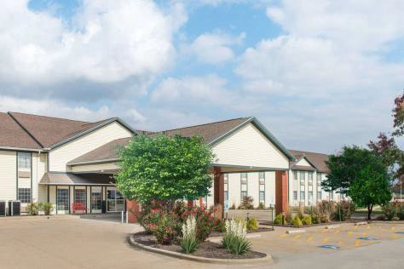
Ramada Springfield North 3281 Northfield Dr
Springfield, IL 62702
(217) 523-4000
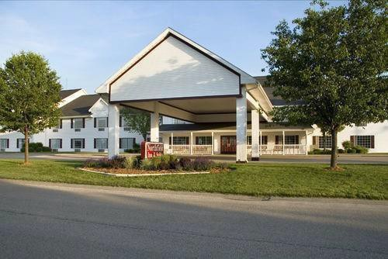
Northfield Inn and Suites 3280 Northfield Dr
Springfield, IL 62702
(217) 523-7900

We are excited to announce our host hotels for this event are the Ramada Springfield North and the Northfield Inn and Suites. Each hotel has a “Courtesy Block” of 10 rooms (standard rooms- double queens or kings) set aside for our show. To book your room in the “Courtesy Block”, call the hotel directly at the number above and ask for the “MGR Goat Show” room block and special rate. There is a discounted rate of $89 plus tax per room for Friday June
1. Reservations will need to be made by May 1, 2018 to secure your room and special rate.

Each hotel has free continental breakfasts, indoor swimming pools, fitness facilities, are completely non- smoking and are a short drive from the IL State Fairgrounds. Your show secretary has stayed at both of these hotels and believe your stay will be enjoyable.

Illinois State Fair Campground:
- Located a short distance South of the North Sheep Barn
- Accommodating RV's, motorhomes, fifth wheels and tents with electric & water hook-ups and limited sewer hook-ups
- Shower & restroom facilities
- Monitored by State Fair Security and Campground Supervisors
- Campers $25/night
- Tents $15/night
For Reservations contact:
217-524-9894 (1130 am - 9 pm) or 217-725-0120 (after hours)

Venue
Located on Historic Route 66, the North Sheep Barn of the Illinois State Fairgrounds in Springfield is home to the 2018 Route 66 Myotonic Classic. The North Sheep barn, constructed in 1980, is an open steel beam building with concrete floor. It features a large show ring with bleacher seating, photo backdrop and platform, metal halide lighting, large metal pens, ceiling fans, restroom facilities and is handicap accessible.
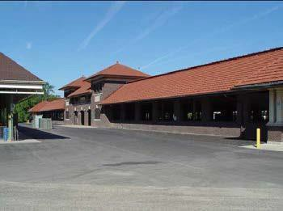
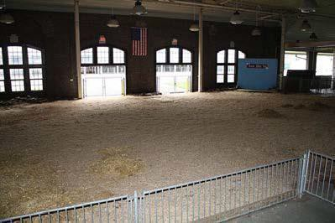
Located at 801 E. Sangamon Ave
2 miles from Interstate 55 (Exit 100B/Sangamon Ave)
Driving Directions: From I-55, exit 100B (Sangamon Ave), drive West on Sangamon Avenue to Gate #11 (Illinois Dept of Ag Building). After entering Gate #11, continue on North 8th Street to the North Sheep Barn (on right).

Dining
Numerous dining options are available throughout Springfield, including:

Sangamon Ave, East of the State Fairgrounds: Fulgenzi’s Pizza & Pasta, Monty’s Submarines, Hardees, Pizza Hut, Subway

North Dirksen Parkway, North of Sangamon Ave: Hickory River Smokehouse (BBQ), Wings Etc, Taco Bell, Burger King, Arbys, Dairy Queen, Culvers, Steak N Shake, Jimmy Johns, Xochimilco Authentic Mexican

South Dirksen Parkway, South of Sangamon Ave: McDonalds, Sonic, Freddys Custard & Steakburgers, Outback Steakhouse, Red Lobster, Smokey Bones BBQ, McAllisters Deli

Other
Memorial and St Johns Hospitals are located downtown. Farm and Home Supply, Big R Farm Store and Super Walmart are on North Dirksen Parkway.

Veterinarian
Should your goats need emergency vet care, our provider, Petersburg Vet Clinic, will be on call for emergency situations.

Show Schedule

Friday, June 1
1:00 - 3:30 p.m.: Check-in/ Registration 3:45 p.m.: Begin line-up
4:00 p.m.: Show A begins
After Show A: Costume Contest

Saturday, June 2
7:00 – 7:30 a.m.: Check-in/ Registration (for those not showing in Show A) 7:45 a.m.: Begin line-up
8:00 a.m.: Show B begins
12:00 p.m.: Lunch break
12:00 - 1:00 p.m.: Check-in/ Registration (for those only showing in Show C) 1:15 p.m.: Begin line-up
1:30 p.m.: Show C begins

*If any exhibitors need to arrive on Thursday May 31st, please contact the Show Secretary as soon as you know your plans*

*If any exhibitors need to stay until Sunday June 3, all exhibitors and goats must be checked-out by 9:00 a.m. sharp. The entire show facility will need to be vacated so the facility can be cleaned out. No exceptions will be allowed. Please contact the Show Secretary as soon as you know if you must stay past Saturday June 2*

*Saturday June 2 Catered Lunch for exhibitors & families by Hickory River Smokehouse
$9 meal/person includes beef brisket or pulled pork sandwhiches, potato salad, coleslaw, scalloped potatoes and drink. The meal will be delivered at 12 noon.
Payment is due at time of check-in prior to Show A or you can pre-register on the Show Registration Form. We need a minimum of 10 people to participate in the lunch, so if we do not get 10, those that pre-paid will receive a refund*

*Bedding- pine shavings or straw are acceptable. You may bring your own or you may purchase pine shavings with your entry forms (must be pre-ordered). The pens are large, so 1 bag/bale may only lightly cover the pen. Exhibitors do not need to clean their pens out at the conclusion of the show*

*Pens- a very spacious setup, there are more pens than needed. Therefore, pens will be assigned to give exhibitors plenty of space but also to keep the clean-up area confined as much as possible. If specific pen assignments are needed, contact the Show Secretary as soon as possible to request those*

*Costume Contest- immediately following the conclusion of Show A, youth and adults (and their goats of course) can enjoy some friendly competition! No entry fee or pre-registration! Winners selected from crowd participation.

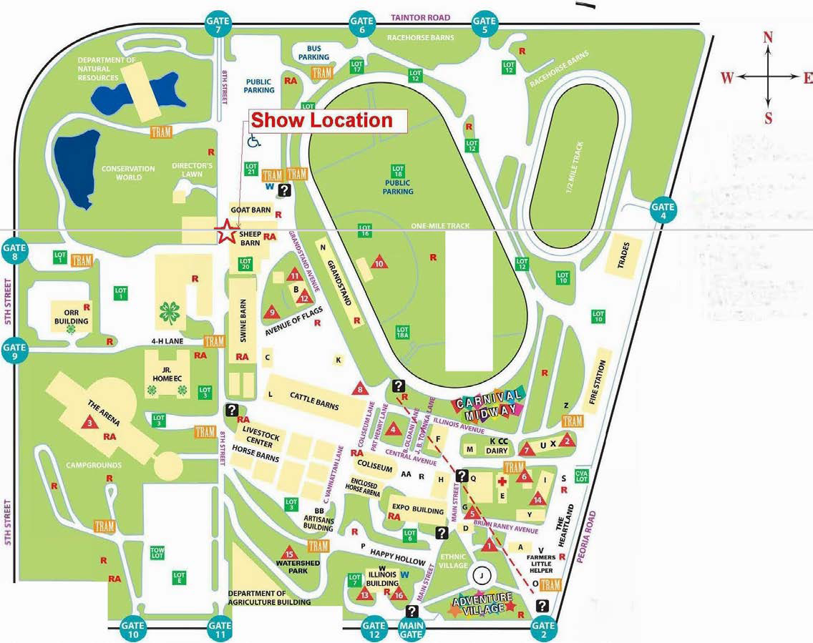
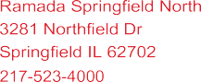
SANGAMON AVENUE
Campgrounds
To Interstate 55, Food, and Lodging

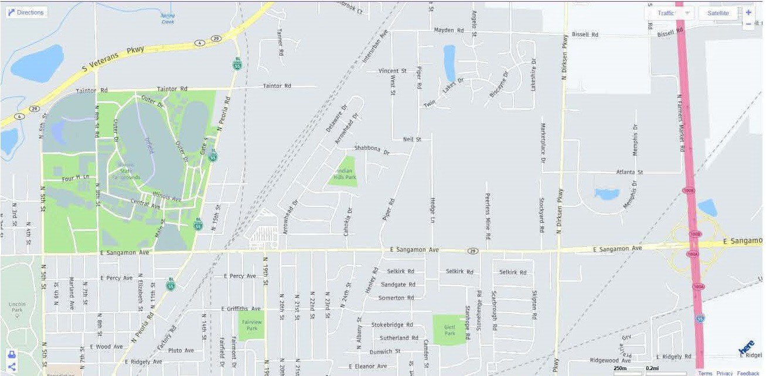
Host Hotels
Gate 11

Route 66 Myotonic Classic
Wallace’s Crazy Acres Show A @ 4:00 pm (6/1/2018) Naughty Goat Acres Show B @ 8:00am (6/2/2018) Bureau Creek Family Farm Show C @ 1:30 pm (6/2/2018) Illinois State Fairgrounds, Springfield Illinois
June 1st and 2nd 2018
CHECK ONE OR MORE
1 | 2 | 3 | GOATS REGISTERED NAME (MUST BE AS ON REG. CERT.) | S E X | D.O.B | MGR REG.  # | Permanent Tattoo, Tag or Microchip | CLASS

PRINT NAME (AS ONREG. CERTIFICATE) SIGNATURE

ADDRESS CITY STATE ZIP

E-MAIL ADDRESS (to address questions) TELEPHONE NUMBER (required)
# OF MGR REGISTERED GOATS X $8.00 PER GOAT/PER CLASS IN SHOWA=$
# OF MGR REGISTERED GOATS X $8.00 PER GOAT/PER CLASS IN SHOWB=$
# OF MGR REGISTERED GOATS X $8.00 PER GOAT/PER CLASS IN SHOWC=$
Number of goat pens x $10.00 per pen =$

Saturday Lunch X $9 per person =$ Bedding—$5 per bale shavings (1 bale lightly covers 1 pen) & MUST be preordered= $ Please note: All goats brought into the facility must be ENTERED in at least 1 of the shows. Grand Total $
Mail To: Drew DeRiemacker – Show Secretary; 2315 Parkes Kinner Rd, Pleasant Plains IL
62677
Please make all checks payable to: Drew DeRiemacker
Statement of liability:
The Show Management will not be responsible for any loss or damage that may occur. Each exhibitor will be solely responsible for their own liabilities, if incurred, as well as damage or injury to any other person or property caused by the exhibitor or animals they exhibit.

CHECK ONE OR MORE

Route 66 Myotonic Classic

1 | 2 | 3 | GOATS REGISTERED NAME (MUST BE AS ON REG. CERT.) | S E X | D.O.B | MGR REG.  # | Permanent Tattoo, Tag or Microchip | CLASS

Entries Form for Showmanship CHECK ONE OR MORE
A | B | C | Youth’s Name | Age of Breeder | Goats name | MGR REG.  # | CLASS  #

Print Name |  | Signature
Address | City | State | Zip Code
Phone Number |  | Email

Any MGR registered doe or wether may be used for showmanship. The goat must have a health certificate.

Statement of liability:
The Show Management will not be responsible for any loss or damage that may occur. Each exhibitor will be solely responsible for their own liabilities, if incurred, as well as damage or injury to any other person or property caused by the exhibitor or animals they exhibit.

Route 66 Myotonic Classic

Wallace’s Crazy Acres Show A @ 4:00 pm (6/1/2018) Naughty Goat Acres Show B @ 8:00am (6/2/2018) Bureau Creek Family Farm Show C @ 1:30 pm (6/2/2018)

Illinois State Fairgrounds, Springfield Illinois June 1st and 2nd 2018

MGR Rules to govern and to take precedence over all others.

Schedule of Classes
- Pee- Wee Showmanship ( Free to all children under 6yrs)
- Youth Junior Showmanship (Free to all youth 6yrs – 9yrs)
- MGR Youth Junior Showmanship (Free to Jr. Breeders 6yrs – 9yrs)
- MGR Youth Jr. High Showmanship (Free to Jr. Breeders, 10 yrs-14yrs)
- MGR Youth Senior Showmanship (Free to Jr. Breeders, 15yrs – 18yrs)
(Classes 3, 4, 5 are open to MGR Youth Breeders only)

MGR Champion Showmanship
(Selected from the 1st and 2nd place youth in classes 3-5)

Doe Show - Junior Does
- Pee Wee Doe Kids: 0 to 3 months of age
- Doe Kids: 3 to 6 months ofage
- Junior Doe Kids: 6 to 9 months of age
- Intermediate. Doe Kids: 9 to 12 months of age
- Yearling Doe - Jr. Unfreshened: 12 to 18 months of age
- Yearling Doe - Jr. Unfreshened: 18 to 24 months of age

Junior Champion & Reserve Junior Champion Doe
(Selected from the 1st and 2nd place animals in classes 5 - 10)

Doe Show - Senior Does
- Yearling Doe -Sr. Freshened: 12 to 18 months of age
- Yearling Doe -Sr. Freshened: 18 to 24 months of age
- Junior Adult Does: 24 to 36 months of age
- Adult Does: 36 to 48 months of age
- Senior Does: 48 to 60 months of age
- Senior Does: 60months of age and older
- Mini-Does: Does that have been certified as Mini and status documented on their registration papers by MGR.
.
Senior Champion & Reserve Senior Champion Doe
(Selected from 1st and 2nd place animals in classes 11 - 20)
Grand Champion & Reserve Grand Champion Doe
(Selected from the Jr. Ch., Res. Jr. Ch.,Sr. Ch. & Res. Sr. Ch. Does)

Buck Show - Junior Bucks
- Pee Wee Buck Kids: 0 to 3 months of age
- Junior Buck Kids: 3 to 6 months of age
- Intermediate Buck Kids: 6 to 9 months of age
- Senior Buck Kids: 9 to 12 months of age

Junior Champion & Reserve Junior Champion Buck
(Selected for the 1st & 2nd place animals in classes 18 - 21)

Buck Show - Senior Bucks
- Yearling Bucks: 12 to 18 months of age
- Yearling Bucks: 18 to 24 months of age
- Junior Adult Bucks: 24 to 36 monthsof age
- Adult Bucks: 36 to 48 months of age
- Senior Bucks: 48 to 60months of age
- Senior Bucks: 60 months of age and older
- Mini-Bucks: Bucks that have been certified as Mini and status documented on their registration papers byMGR

Senior Champion & Reserve Senior Champion Buck
(Selected from the 1st & 2nd place animals in classes 22 - 28)

Grand Champion & Reserve Grand Champion Buck
(Selected for the Jr. Ch., Res. Jr. Ch., Sr. Ch. & Res. Sr. Ch.)

Platinum Wether Show - Junior Wethers

- Pee Wee Wether Kids: 0 to 3 months of age
- Junior Wether Kids: 3 to 6 months of age
- Intermediate Wether Kids: 6 to 9 monthsof age
- Senior Wether Kids: 9 to 12 months of age

Junior Champion & Reserve Junior Champion Wether
(Selected from 1st & 2nd place animals in classes 29 -32)

Platinum Wether Show - Senior Wethers
- Intermediate Senior Wether: 12 to 18 monthsof age
- Intermediate Senior Wether: 18 to 24 monthsof age
- Adult Wether: 24 to 36 months of age
- Senior Wether: 36 months of age and over

Senior Champion & Reserve Senior Champion Wether
(Selected from the 1st & 2nd place animals in classes 33 - 36)
Grand Champion & Reserve Grand Champion Wether
(Selected from the Jr. Ch., Res. Jr. Ch., Sr. Ch. & Res Sr. Ch.)

Market Wether Show – Light-Weight Market Wethers

- Light Weight Wether: 0 to 3 months of age
- Light Weight Wether: 3 to 6 months of age

Champion Light -Weight & Reserve Champion Light -Weight Wether
(Selected from 1st & 2nd place animals in classes 37 thru 38)

Market Wether Show – Heavy-Weight Market Wethers

- Heavy-Weight Market Wether: 6 to 9 months of age
- Heavy-Weight Market Wether: 9 to 12 months of age
(Wethers may show in class 40 until there is evidence of permeant teeth)

Champion Heavy-Weight & Reserve Champion Heavy-Weight Wether
(Selected from the 1st & 2nd place animals in classes 39 thru 40)

Grand Champion Market & Reserve Grand Champion Market Wether (Selected from the Ch. Light Weight, Reserve Ch. Light Weight, Ch. Heavy Weight & Res Ch. Heavy Weight)

